Full Stack Development with MERN
Project Documentation format
1. Introduction
• Project Title: Customer Registry
• Team Members:
Team ID: SWTID-2026-9658
Core Engineering & Full-Stack Development:
- Mounika Chittoor (Team Lead)
- Monika Dondeti
- Meghana Siddamurthy
- Gummagatta Naveen Kumar
- Kariyappagari Manjunatha

2. Project Overview
• Purpose: The purpose of the Customer Care Registry is to provide a clean, secure, and fast platform where customers can easily log complaints and interact directly with support agents to resolve technical issues or operational grievances.
• Features:
- Secure user signup, login authentication, and state management.
- Single-page multi-parameter forms for creating customer tickets.
- Role-based visibility displaying a customer-specific complaint history track and a centralized administrator department queue.
- Seamless communication history channels powered by text-based messaging between customers and support executives.

3. Architecture
- Frontend: A modern Single Page Application (SPA) designed using React 19 and Vite. It leverages React Client-Side Routing for transition layers and utilizes Context Providers to enforce global session authentication rules across pages
- Backend: Built using Node.js and the Express.js v5 web routing framework. The server handles application routing middleware logic, processes asynchronous requests, prints operational requests to log parameters, and implements global error handling.
- Database: Powered by a non-relational MongoDB Document Database framework managed via the Mongoose Object-Document Mapper (ODM). Data models define robust validations for users, complaints, and interaction messages
4. Setup Instructions
• Prerequisites:Node.js runtime environment installed locally.
MongoDB Community Server local instance or an active cloud cluster connection (MongoDB Atlas).
Installation: Clone the project repository:
https://github.com/chittoormounika0309-ops/Customer--Registry
set up Backend Dependencies:
Bash
cd server
npm install
Configure Environment Variables: Create a .env file inside your /server directory:
Code snippet
PORT=5000
MONGO_URI=your_mongodb_connection_string
JWT_SECRET=your_jwt_encryption_key
Set up Frontend Dependencies:
Bash
cd ../client
npm install
5. Folder Structure
• Client:
Customer---Care/
├── client/ # React Frontend Application (Vite Build)
│ ├── public/ # Static assets (favicons, icons)
│ ├── src/ # Component Logic & Views
│ │ ├── context/ # AuthContext global user session data
│ │ ├── pages/ # View Screens (Home, Login, SignUp, WriteComplaint, etc.)
│ │ └── App.jsx # Client-side route declarations
│ ├── package.json # Frontend package dependencies & scripts
│ └── vite.config.js # Vite build environment configuration
│
└── server/ # Node.js Backend Application
├── controllers/ # Request handler processing logic
├── models/ # Mongoose schemas (User, Complaint, Message)
├── routes/ # Express API endpoint mapping modules
├── db.js # Database connectivity setup code
├── server.js # Application middleware stack configuration
├── index.js # System bootstrapping & server network listener
└── package.json # Backend configuration & reliance scripts

6. Running the Application
• Provide commands to start the frontend and backend servers locally. oFrontend: cd client npm run dev
OBackend: cd server npm start

7. API Documentation
All core routes map directly to exposed JSON API nodes:
- POST /api/auth/signup: Registers a new system account securely using bcryptjs hashing.
- POST /api/auth/login: Authenticates credentials and returns a secure authorization token signature.
- GET /api/complaints: Fetches registered customer care logs based on individual or agent credential flags.
- POST /api/complaints: Submits a valid ticket layout record container directly into the database.
- POST /api/messages: Publishes synchronous support messaging conversations to the user dashboard queue.

8. Authentication
• Authentication is securely completed via stateless JSON Web Tokens (JWT) combined with backend Bcrypt password encryption fields.
Upon validating accurate logins, the server builds an encrypted signature token and returns it. The React layout layer captures this value, updates the dynamic state inside the application's root via <AuthProvider>, and securely appends the authorization header into all future outgoing axions requests.

9. User Interface
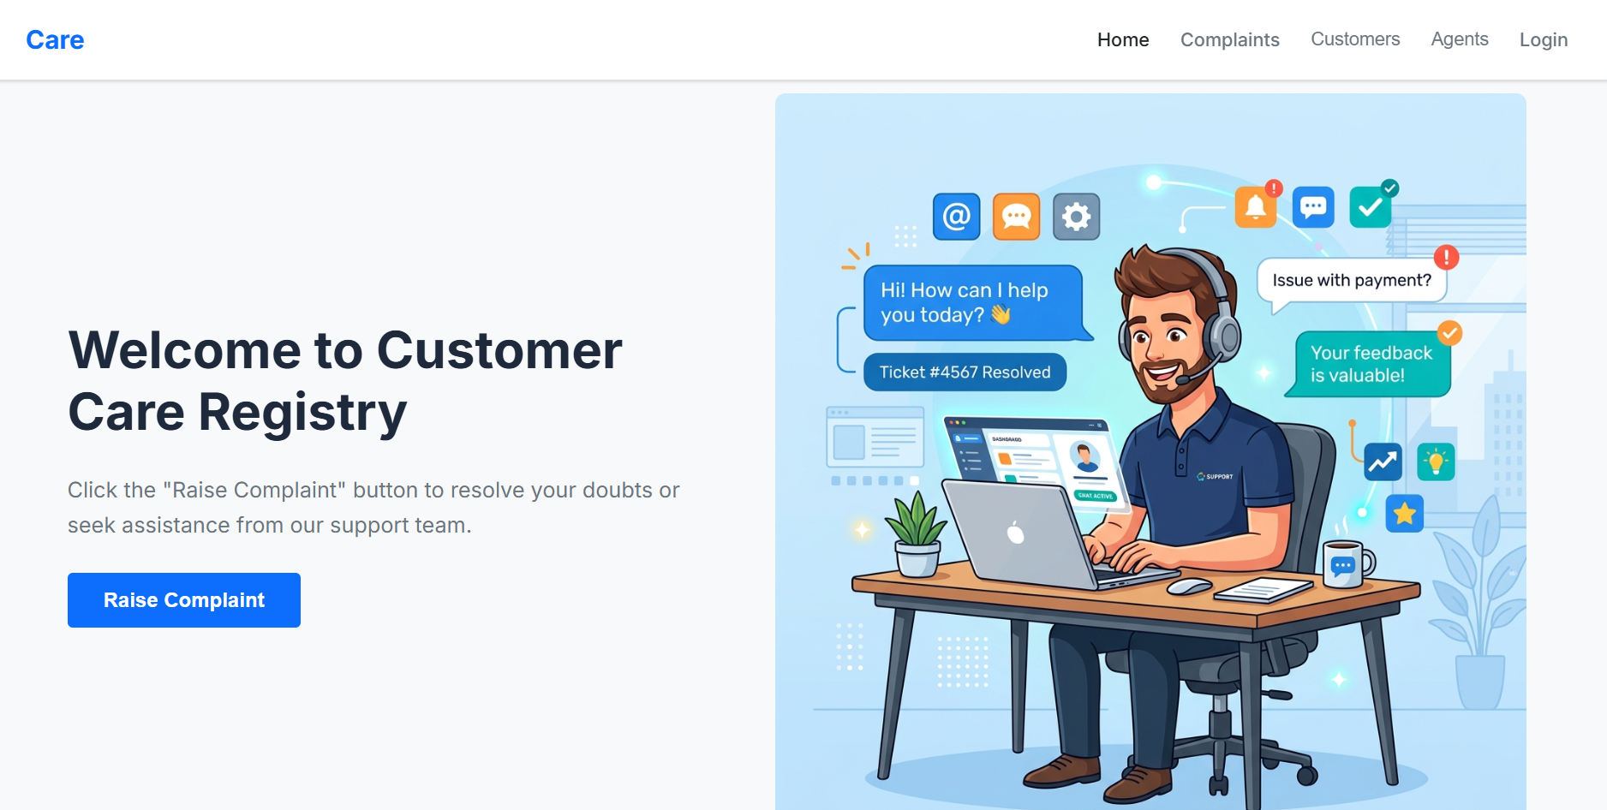

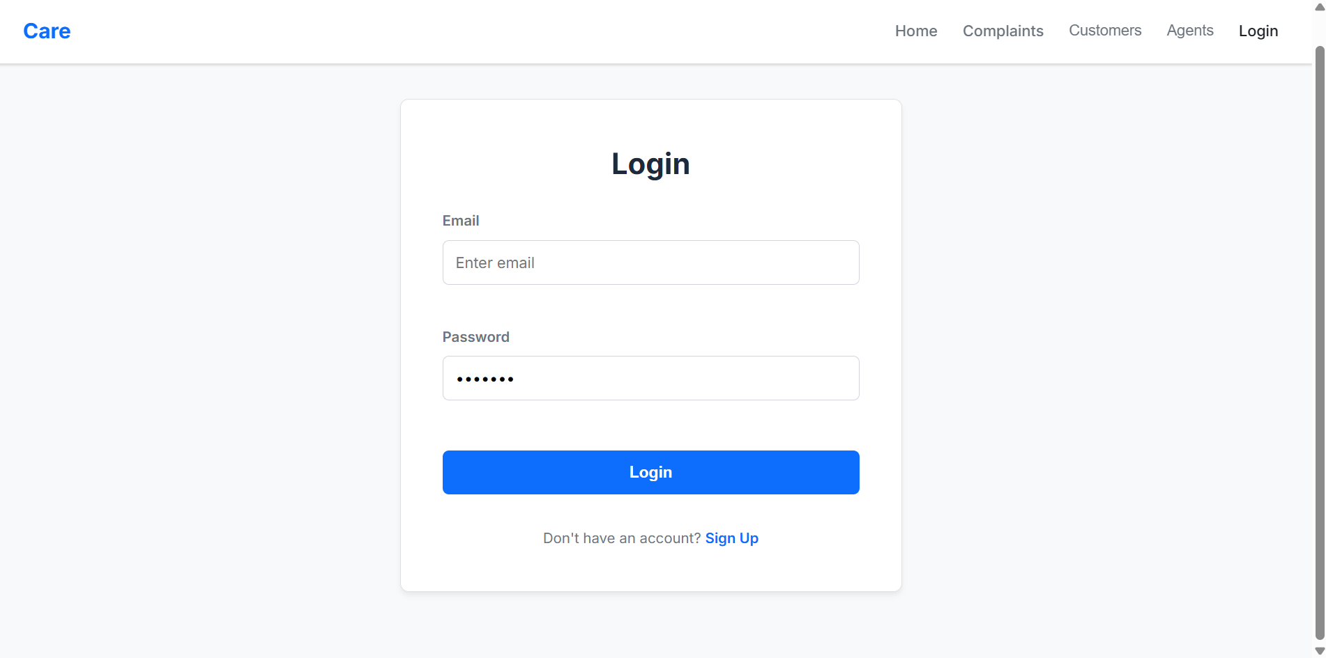
10. Testing
- Backend endpoint verification is performed locally using API evaluation utilities to track dynamic payload requests and ensure that response status formats remain accurate under error testing scripts.
- Frontend build pipelines are controlled via structural code evaluations using structural code compilation tools (oxlint) to prevent dead code blocks or performance layout errors.

11. Screenshots or Demo
•Repository Link: https://github.com/chittoormounika0309-ops/Customer--Registry
12. Known Issues
- •Currently, the background execution architecture handles connections safely; however, missing environment configuration parameters will trigger a manual database fallback logic alert within the system connection window during initial local initialization phases.
13. Future Enhancements
- Adding support for localized dynamic configuration grids enabling customized input parameters for user tickets.
- Introducing physical interactive communication registries allowing customer service executives to trace telephone conversation logs or scheduled physical review appointments manually from the admin control panel.

